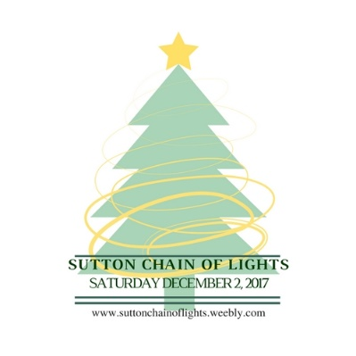
Sutton Chain of Lights
Sponsorship Packages
Saturday December 2nd, 2017
10am-4pm

Thank you for your consideration in sponsoring the Sutton Chain of Lights. Your generosity and involvement is greatly appreciated. We are willing to work with you to create the most value for your business through your sponsorship should any of these packages not fit your desires.
Presenting Sponsor: $1500
- Recognized in brochure with company logo
- Recognized on all social media platforms and press releases
- Presenting Sponsor Logo attached to all Trolley Signs and an individual full trolley sponsor sign Recognition Statement read on ALL trolleys
- Recognized on Event Information Board at the Trolley Hub with logo

Trolley Sponsor: $1000
- Recognized in brochure
- Recognized on social media
- Individual full trolley sponsor sign Recognition statement read on
individual trolley
- Recognized on Event Information Board at the Trolley Hub with logo

Marketing Sponsor: $500
- Recognized in brochure
- Recognized on social media
- Recognized on Event Information Board at the Trolley Hub with logo

Event Sponsor: $200
- Recognized in brochure
- Recognized on social media
- Recognized on Event Information Board at the Trolley Hub with logo

Event Supporter: $100
- Recognized in brochure
- Recognized on social media
- Recognized on Event Information Board
at the Trolley Hub

Company Name: ____________________________________________________________
Company Contact: ___________________________________________________________
Phone: _____________________ Email: _______________________________________
Address: ___________________________________________________________________
Sponsorship Level: ____________ Amount Enclosed: ______________________________
Checks can be made payable to: Sutton Chain of Lights and mailed to:
Sutton Chain of Lights
7 Douglas Pike
Sutton, MA 01590

Checks must be received by September 1, 2017 to be printed in the brochure
Event details: www.suttonchainoflights.weebly.com

